**Internship Documentation :**

**Company Name : Akash Technolab**

**Internship technology : PHP**

**Submitted By : Ronakbhai Bharatbhai Bhalala**

**Date : 27/05/21**

**Task 1 :**

**Practice :**

**Program 1 : Use for loop and validation of it.**

<?php

echo "<table border='1'>";

for($i=0;$i<1000;$i++){

echo "<tr>";

if($i%2==0){

echo"<td bgcolor='cyan'>$i</td>";

}else{

echo"<td color='pink'>$i</td>";

}

echo "</tr>";

}

echo "</table>";

?>

**Output:**

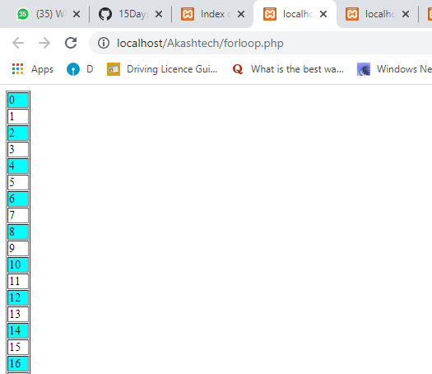

**Program 2 : Odd Even using form.**

<html>

<body>

<form method="post">

Enter a number:

<input type="number" name="number">

<input type="submit" value="Submit">

</form>

</body>

</html>

<?php

if($_POST){

$number = $_POST['number'];

//divide entered number by 2

//if the reminder is 0 then the number is even otherwise the number is odd

if(($number % 2) == 0){

echo "$number is an Even number";

}else{

echo "$number is Odd number";

}

}

?>

**Output:**

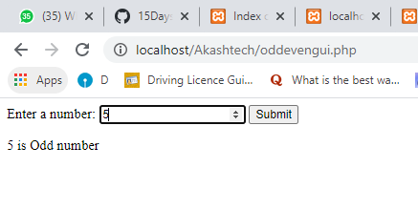

**Program 3 : Leap year using Form.**

<html>

<body>

<form method="post">

Enter the Year: <input type="text" name="year">

<input type="submit" name="submit" value="Submit">

</form>

</body>

</html>

<?php

if($_POST)

{

//get the year

$year = $_POST['year'];

//check if entered value is a number

if(!is_numeric($year))

{

echo "Strings not allowed, Input should be a number";

return;

}

//multiple conditions to check the leap year

if( (0 == $year % 4) and (0 != $year % 100) or (0 == $year % 400) )

{

echo "$year is a Leap Year";

}

else

{

echo "$year is not a Leap Year";

}

}

?>

**Output:**

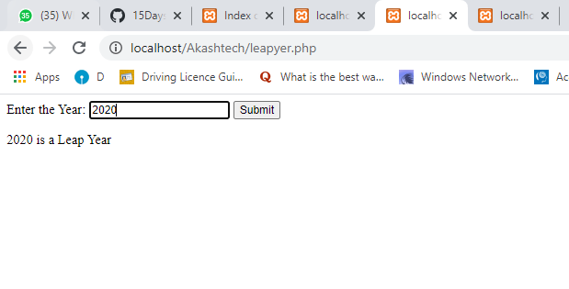

**Program 4 : Subtraction Using Form.**

<html>

<body>

<form method="post">

Enter First Number:

<input type="number" name="number1" /><br><br>

Enter Second Number:

<input type="number" name="number2" /><br><br>

<input type="submit" name="submit" value="Subtract">

</form>

<?php

if(isset($_POST['submit']))

{

$number1 = $_POST['number1'];

$number2 = $_POST['number2'];

$sum = $number1-$number2;

echo "The difference of $number1 and $number2 is: ".$sum;

}

?>

</body>

</html>

**Output:**

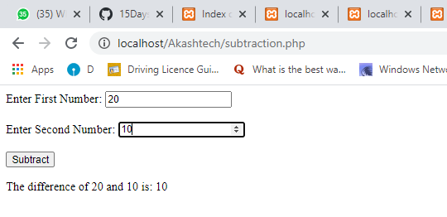

**Program 5 : Area of triangle Using Form.**

<html>

<body>

<form method = "post">

Base: <input type="number" name="base">

<br><br>

Height: <input type="number" name="height"><br> <br>

<input type = "submit" name = "submit" value="Calculate">

</form>

</body>

</html>

<?php

if(isset($_POST['submit']))

{

$base = $_POST['base'];

$height = $_POST['height'];

$area = ($base*$height) / 2;

echo "The area of a triangle with base as $base and height as $height is $area";

}

?>

**Output:**

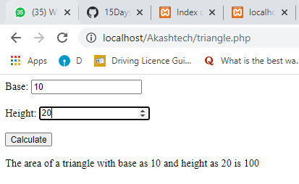

**Task 2 :**

**Code:-**

**1. Registration form : Using Get and post method, display data in next page.**

**Using Post:**

<!DOCTYPE html>

<html>

<head>

<title>Task-3 : php form.</title>

<meta name="viewport" content="width=device-width, initial-scale=1.0">

<link rel="stylesheet" href="https://maxcdn.bootstrapcdn.com/bootstrap/4.5.2/css/bootstrap.min.css">

<style type="text/css">

body{

background-image: linear-gradient(HotPink, cyan);

}

</style>

</head>

<body>

<h1 align="center">Task-3 : Method using Post Form.</h1>

<h1 align="center">Registration Form</h1>

<form action="task3.php" method="POST" class="formgroup">

<div class="container">

<div>

<label for="uname"><b> Name : </b></label>

<input class="form-control" type="text" name="uname" required>

</div><br>

<div>

<label for="email"><b>EMail : </b></label>

<input class="form-control" type="email" name="email" required>

</div><br>

<div>

<label for="phone"><b>Phone : </b></label>

<input class="form-control" type="text" name="phone" required>

</div><br>

<div>

<label for="pwd"><b>Password :</b> </label>

<input class="form-control" type="password" name="pwd" required>

</div><br>

<button type="submit" class="btn btn-primary" name="submit">Submit</button>

<button type="reset" class="btn btn-primary" name="submit">Reset</button>

</div><br>

</form>

</body>

</html>

**task3.php**

<html>

<head>

<style type="text/css">

body{

background-image: linear-gradient(HotPink, cyan);

}

</style>

</headsss>

<body>

<h1>

Your Name is <?php echo $_POST["uname"]; ?>.<br>

Your Email address is <?php echo $_POST["email"];?>.<br>

Your Mobile Number is <?php echo $_POST['phone'];?>.

<br>

Your Password is <?php echo $_POST["pwd"];

?>.

</h1>

</body>

</html>

**Output:**

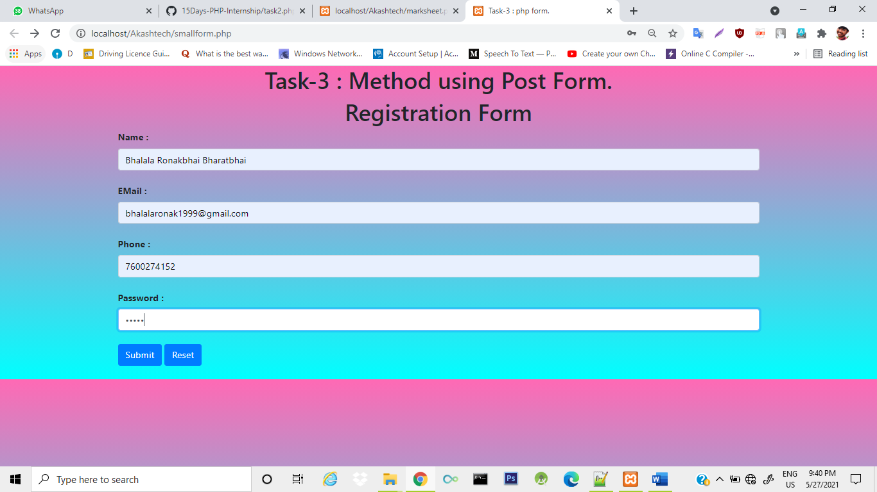

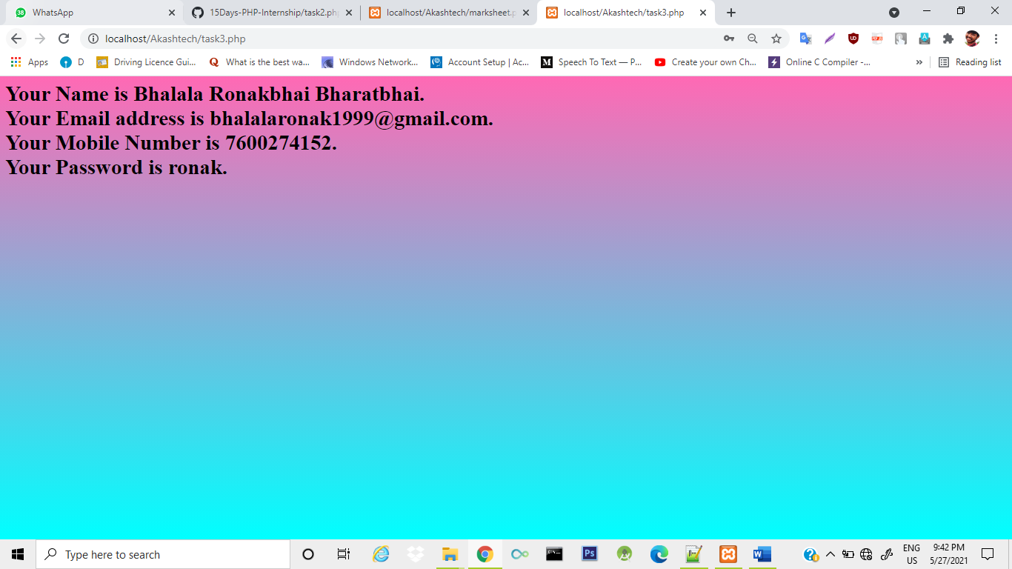

**Using Get:**

<!DOCTYPE html>

<html>

<head>

<title>Task-3 : php form.</title>

<meta name="viewport" content="width=device-width, initial-scale=1.0">

<link rel="stylesheet" href="https://maxcdn.bootstrapcdn.com/bootstrap/4.5.2/css/bootstrap.min.css">

<style type="text/css">

body{

background-image: linear-gradient(PapayaWhip, Lime);

}

</style>

</head>

<body>

<h1 align="center">Task-3 : Method using Get Form.</h1>

<h1 align="center">Registration Form</h1>

<form action="task3get.php" method="GET" class="formgroup">

<div class="container">

<div>

<label for="uname"><b> Name : </b></label>

<input class="form-control" type="text" name="uname" required>

</div><br>

<div>

<label for="email"><b>EMail : </b></label>

<input class="form-control" type="email" name="email" required>

</div><br>

<div>

<label for="phone"><b>Phone : </b></label>

<input class="form-control" type="text" name="phone" required>

</div><br>

<div>

<label for="pwd"><b>Password :</b> </label>

<input class="form-control" type="password" name="pwd" required>

</div><br>

<button type="submit" class="btn btn-primary" name="submit">Submit</button>

<button type="reset" class="btn btn-primary" name="submit">Reset</button>

</div><br>

</form>

</body>

</html>

**Output:**

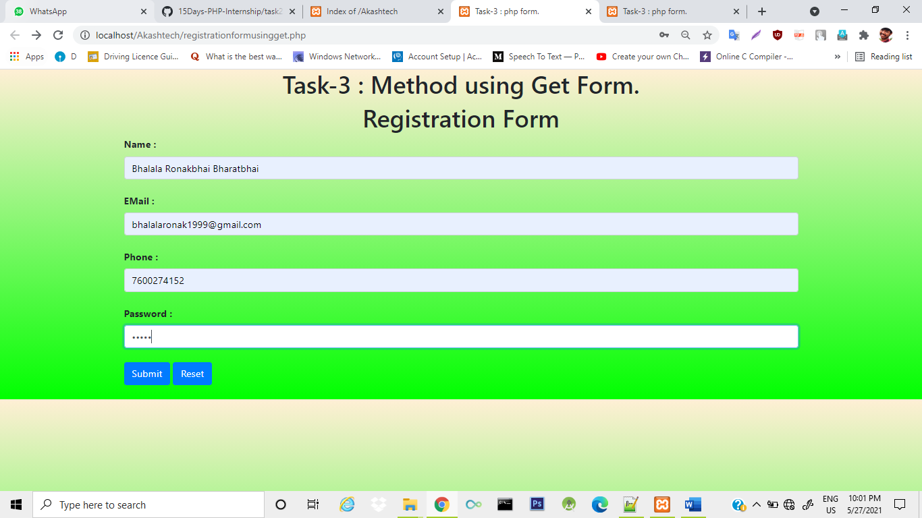

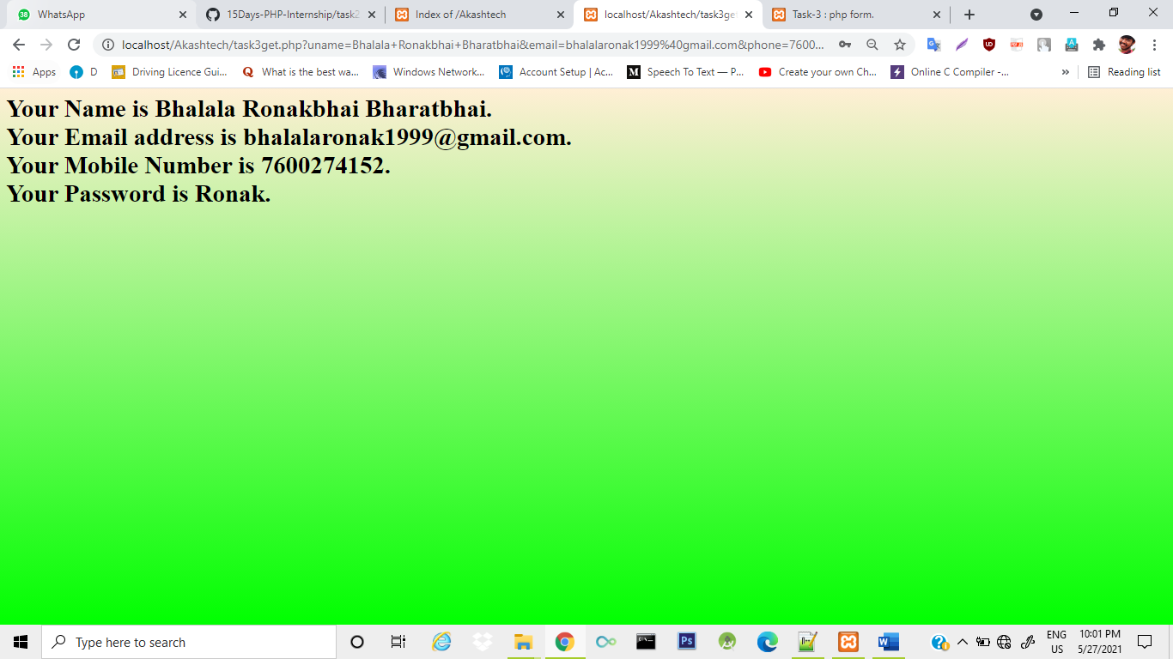

**2. Take 3 subject marks, Display All marks, display total and condition to grade .**

<html>

<body>

<form action="" method="post">

<center>

<h1>Marksheet</h1>

<table border=0 cellpadding=10px>

<tr>

<td>

Student Name

</td>

<td>

<input type=text name="t1" required >

</td>

</tr>

<br>

<tr>

<td>

Marks for Physics

</td>

<td>

<input type=text name="t2" required>

</td>

</tr>

<br>

<tr>

<td>

Marks for Chemistry

</td>

<td>

<input type=text name="t3" required>

</td>

</tr>

<tr>

<td>

Marks for Math

</td>

<td>

<input type=text name="t4" required>

</td>

</tr>

<br>

</table>

<br>

<br>

<input type=submit name="s" value="Result">

</center>

<?php

if(isset($_POST['s']))////checking whether the input element is set or not

{

$a=$_POST['t1']; //accessing value from 1st text box

$a1=$_POST['t2']; //accessing value from 2nd text field

$a2=$_POST['t3']; //accessing value from 3rd text field

$a3=$_POST['t4']; //accessing value from 4th text field

$sum=$a1+$a2+$a3; //total marks

$avg=$sum/3;

if($avg>=0&&$avg<=50)

$grade="Fail";

if($avg>50&&$avg<=70)

$grade="C";

if($avg>70&&$avg<=80)

$grade="B";

if($avg>80&&$avg<=90)

$grade="A";

if($avg>90)

$grade="E";

echo "<br>";

echo "<font size=4><center>Student is:-".$a."</center><br>";

echo "<font size=4><center>Marks for Physics is:-".$a1."</center><br>";

echo "<font size=4><center>Marks for Chemistry is:-".$a2."</center><br>";

echo "<font size=4><center>Marks for Math is:-".$a3."</center><br>";

echo "<font size=4><center>Total marks:-".$sum."</center><br>";

echo "<font size=4><center>Grade is:-".$grade."</center>";

}

?>

</form>

</body>

</html>

**Output:**

